

KINDLY SPONSORED BY

**CONCEPT TAVERNS / THE NORTHERN SNOOKER CENTRE**

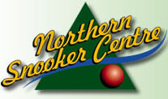 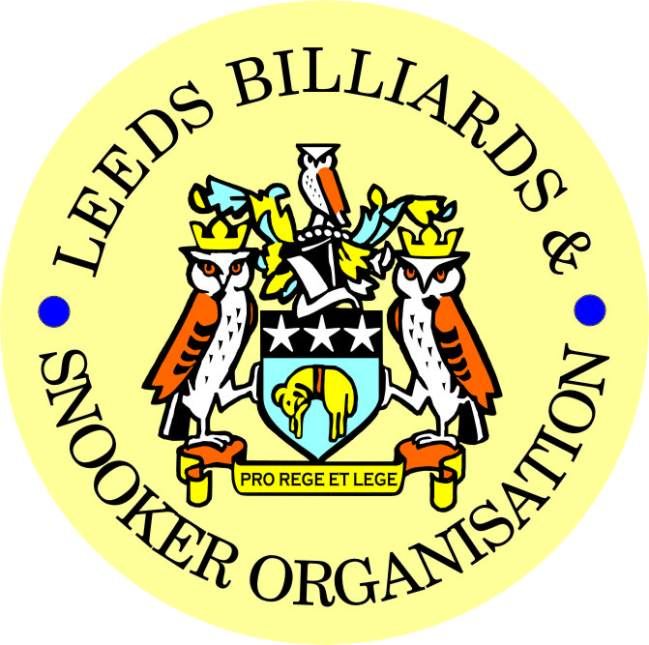 

|  |
| --- |
| ***FINAL – 2023/24 LEEDS CITY SNOOKER CHAMPIONSHIP***  ***& PRIZE PRESENTATION EVENING***  ***WEDNESDAY 12th JUNE 2024***  ***NORTHERN SNOOKER CENTRE*** |

|  |
| --- |
| **2023/24 LEEDS CITY SNOOKER CHAMPIONSHIPS**  **SINGLES FINAL - BEST OF 7 FRAMES**  **RICHARD BINNS (4) v MALCOLM BILCLOUGH (2)**  ***FOLLOWED BY-***   * **PRESENTATION OF THE SINGLES TROPHY & INDIVIDUAL AWARDS-** * **PRESENTATION OF ALL OTHER - 2023/24 LCC – Annual trophies and individual awards** |

|  |  |
| --- | --- |
| **\*\* 2023/24 LEEDS CITY CHAMPIONSHIPS \*\*** | |
| **JUNIORS - UNDER 16’s SNOOKER:**  **Trophy - Presented by ADT Flexibles (UK) Ltd.** | |
| WINNER: **CHARLIE EARNSHAW** | RUNNER-UP: **OSCAR CHAN** |
|  | |
| **JUNIORS - UNDER 18’s SNOOKER:**  **“The Keith Weston Memorial Trophy”- Presented by ADT Flexibles (UK) Ltd.** | |
| WINNER: **DANIEL BOYES** | RUNNER-UP: **DILRAJ RYATT** |
|  | |
| **JUNIOR HIGH BREAK: - “The Paul Hunter Memorial Trophy” – JAMES PEARS (57)** | |

|  |  |
| --- | --- |
| **INDIVIDUAL SNOOKER:** | |
| WINNER: **RICHARD BINNS** | RUNNER-UP: **MALCOLM BILCLOUGH** |
| SEMI-FINAL: **GAVIN GODFREE** | SEMI-FINAL: **DANIEL BOYES** |
| **PAIRS SNOOKER:**  **Trophy - Presented by ADT Flexibles (UK) Ltd.** | |
| WINNERS: **LEE BROOKES & JAMES PEARSON** | RUNNERS-UP: **G. GODFREE & L.HARPER** |
| SEMI-FINAL: **P. METCALF & M. McGUIGAN** | SEMI-FINAL: **A. RENNISON & L.CAMPEY** |
| **TEAM SNOOKER – “The Jim Fowler’s Trophy”:** | |
| WINNERS: **BELLE ISLE WMC** | RUNNERS-UP: **GARFORTH WMC** |

|  |
| --- |
| ***2023 / 2024 - *PRIZE PRESENTATION EVENING\****  ***WEDNESDAY 17th JULY 2024***  ***SOUTH LEEDS CONSERVATIVE CLUB*** |

|  |  |
| --- | --- |
| **SNOOKER - “Veterans Trophy” – 50+**  **“The Rodney Sims Memorial Trophy”**  **Presented by the LBSO** | **REFEREES:**  **Officiated in 2023-24 LBSO Competitions:** |
| **WINNER: ROBERT KENNALLY** | **ANDY KITSON** |
| **RUNNER-UP: DAVID HORRY** | **MICHAEL DAVENPORT** |
|  | **PAUL MARLOW** |
| **PLATE WINNER: DAVE BOYES** | **MARK BALL** |
| **PLATE RUNNER-UP: PAUL GRIMES** | **BOB PATTERSON** |

|  |  |  |
| --- | --- | --- |
| **\*\* LBSO - SNOOKER LEAGUES \*\*** | | |
| **Div:** | **CUP TITLE / WINNERS:** | **RUNNERS-UP:** |
| **Div A** | **The Yorkshire Evening News Shield:**  **MIDDLETON CONS ‘A’** | **SWARCLIFFE WMC ‘A’** |
| **Div B** | **The J. McDonnell / J. Williamson Trophy:**  **MORLEY WMC & INST. ‘A’** | **NEW HEADINGLEY ‘A’** |
| **Div C** | **The John Dunning Trophy:**  **BRAMLEY WMC ‘C’** | **NORTHERN SC ‘B'** |
| **Div D** | **The Jerry Bird Memorial Trophy:**  **GARFORTH WMC ‘A’** | **MOOR ALLERTON SPORTS & SOCIAL CLUB ‘A’** |
| **Div E** | **The Peter Nelson Trophy:**  **MIDDLETON CONS ‘B’** | **MENSTONE MEMBERS BAR & SNOOKER CLUB ‘A’** |
| **Div F** | **The Peter Hawkyard Memorial Trophy:**  **HUNSLET CARR SPORTS & SOCIAL CLUB** | **CALVERLEY CONSERVATIVE**  **CLUB** |

|  |  |
| --- | --- |
| **“CHAMPION of CHAMPIONS”**  **“The Jim Williamson Memorial Trophy”**  **Presented by the Northern Snooker Centre** | WINNERS: **GARFORTH WMC ‘A’**  **(DIVISION D WINNERS)** |

|  |  |  |
| --- | --- | --- |
| **LBSO - LEAGUE & COMPETITIONS – SNOOKER HIGHEST BREAKS**  **HIGHEST BREAK TROPHY**  **Presented by ADT Flexibles (UK) Ltd. in 2019** | | |
| **Break** | **League / Competition** | **Player (Team)** |
| **134 +**  **(126 / 100 / 100)** | **LEN LEE INVITATION /**  **(LCC’S & DIVISION A)** | **RICHARD BINNS**  **(BELLE ISLE WMC)** |
| 132 | LCC SINGLES | DANIEL WORMESLEY (NSC) |
| 114 | LEAGUE DIVISION E | GYLES BEHBOOD (MENSTONE B+S) |
| 111 | LEAGUE DIVISION F | MALCOLM BILCLOUGH (HORSFORTH C) |
| 99 | LEAGUE DIVISION A | LEE ATKINSON (MAIN LINE SOCIAL) |
| 90 | LEAGUE DIVISION D | JAMES PEARSON (GARFORTH WMC) |
| 87 | LEAGUE DIVISION F | BARRY FRANKLAND (HORSFORTH CON) |
| 86 & 85 | LEAGUE DIVISION A | LEWIS HARPER (EXCELSIOR SC) |

|  |  |
| --- | --- |
| LEN LEE INVITATION SNOOKER – (Scratch):  **“THE LEN LEE TROPHY”**  **Trophy presented by**  **ADT Flexibles (UK) Ltd**  **for 2020** | WINNER: **RICHARD BINNS (BELLE ISLE WMC)**  RUNNER-UP: **MARK BALL (FARSLEY CONS)** |

|  |  |
| --- | --- |
| **SNOOKER – SYKES CUP - Individual Handicap.**  **The “GEORGE SYKES CUP”** | |
| WINNER: **IAN LONGBOTTOM**  **(FARSLEY CONS)** | RUNNER-UP**: DAVE FRENCH**  **(CROSSGATES REC. HALL)** |
| SEMI-FINAL: **TIM SMITH**  **(HORSFORTH CONS)** | SEMI FINAL: **SAM O’BRIEN**  **(HAREHILLS WMC)** |

|  |  |
| --- | --- |
| **SNOOKER – LEN LEE PAIRS - Pairs Handicap.**  **The “LEN LEE CUP”** | |
| WINNERS: **T. OATES & D. MILLWARD**  **(ROWLAND ROAD)** | RUNNERS-UP:**D. BOYES (Jun) & D. BOYES (Sen)**  **(GILDERSOME CONS)** |
| SEMI-FINAL- **C. TOWNEND & L. TOWNEND**  **(BARNBOW VILLAGERS)** | SEMI-FINAL: **D. CONNELLY & J. HATTON**  **(HAREHILLS LIBS)** |

|  |  |
| --- | --- |
| **SNOOKER - 3 MAN TEAM KNOCK OUT – Handicap.**  **The “3 Man Knock Out Trophy”** | |
| WINNERS: **MOOR ALLERTON S+S CLUB** | RUNNERS-UP- **GILDERSOME CONS** |
| SEMI-FINAL: **PUDSEY LIBERAL CLUB** | SEMI FINAL:  **ROWLAND ROAD WMC** |

|  |  |
| --- | --- |
| **\*\* STAN BROOKE MEMORIAL COMPETITIONS \*\***  **(AGGREGATE SCORES – 3/4 FRAMES)** | |
| **INDIVIDUAL SNOOKER – 3 FRAMES:** | |
| WINNER: **JIMMY DOHERTY**  **(DENISON HALL)** | RUNNER-UP**: SHAUN DEWENDY**  **(EDMUND HOUSE)** |
| SEMI-FINAL: **PHIL MORTON**  **(FARSLEY CONS)** | SEMI FINAL: **BEN THORNTON**  **(NEW MIDDLETON)** |
| **PAIRS SNOOKER – 3 FRAMES:** | |
| WINNERS: **D. SCARLETT & G. SMITH**  **(BEECHWOOD WMC)** | RUNNERS-UP:  **T. DOHERTY & J. DOHERTY**  **(DENISON HALL)** |
| SEMI-FINAL: **R. KENNALLY & C. KENNALLY**  **(BRAMLEY WMC)** | SEMI-FINAL: **P. WHINCUP & N. WHITTAKER**  **(HORSFOTH CONS)** |
| **TEAM SNOOKER – 4 FRAMES:** | |
| WINNERS: **BELLE ISLE WMC** | RUNNERS-UP: **GARFORTH WMC** |
| SEMI-FINAL: **CORNER HOUSE CLUB** | SEMI-FINAL: **BRAMLEY WMC** |

|  |  |
| --- | --- |
| **The “WINDSOR TROPHY” – 4 Man Team Handicap**  **Presented by ADT Flexibles (UK) Ltd.** | |
| WINNERS: **ROWLAND ROAD WMC** | RUNNERS-UP:  **FARSLEY CONS** |
| SEMI-FINAL: **BRUNTCLIFFE WMC** | SEMI FINAL: **BELLE ISLE WMC** |

***CONGRATULATIONS!***

***TO ALL PRIZE WINNERS FOR 2023-24***

**The LBSO would like to thank-:**

1. **Concept Taverns / the Northern Snooker Centre for staging the final of the 2023/24 Leeds City Snooker Singles Championship and the 1st presentation of all 2023/24 Leeds City Champions**

**On 12th June this year,**

**and also**

1. **South Leeds Conservative Club for staging tonight’s 2nd presentation of all other awards for the 2023/24 season.**

|  |
| --- |
| Presented By-  C:\Users\user\Pictures\Miscellaneous\LBSO Logo.jpg  ***CURRENT LBSO COMMITTEE MEMBERS***  *PRESIDENT – CHRIS WILLIAMSON*  *CHAIRMAN – ANDY TAFFINDER*  *VICE CHAIRMAN –*  *LEAGUE SECRETARY – PAUL GRIMES*  *COMPETITION SECRETARIES – MARK BALL & PAUL MARLOW*  *GENERAL SECRETARY / TREASURER – BOB PATTERSON*  **A DATE FOR YOUR DIARY:**  **\*\*11th SEPTEMBER 2024\*\***  **START OF THE 2024/25 LEAGUE SEASON** |

**Kindly Sponsored by the**

**CONCEPT TAVERNS / ‘NORTHERN SNOOKER CENTRE’**

  